Bmad Lattice to Blender or Inventor

[Document subtitle]

David Burke (CLASSE), Joe Conway (XELERA Research Inc.) Chris Mayes (XELERA Research Inc.)

[Year]

Contents

History 1

Scope 1

Introduction 1

Definitions/Abbreviations 1

Bmad 1

Coordinate Systems 1

Bmad 1

Inventor 2

Blender 2

Inventor 3

Blender 3

Appendices 3

# History

Within CLASSE, Joe Conway thought about this concept from the time of designing the ILC Damping ring with the CESRTA project (~2011). Dave Burke had the same idea when starting the CBETA design and he and Joe revisited the idea and with Joe’s concept Dave implemented a solution that he used to engineer the CBETA accelerator (~2017). For Xelera’s project designing the Strong Hadron Cooling ERL for BNL’s upgrade, Joe used the concept for engineering design. In parallel, Chris Mayes has helped by exporting *.csv files from Bmad that Joe and Dave used as inputs and himself created python code to create lattice models in Blender.

# Scope

The quick brown fox jumped over the lazy dog.

# Introduction

The quick brown fox jumped over the lazy dog.

# Definitions/Abbreviations

The quick brown fox jumped over the lazy dog.

# Bmad

The quick brown fox jumped over the lazy dog.

# Coordinate Systems

## Bmad

Y up, X radially out (in typical clockwise circular accelerator), Z direction of Beam

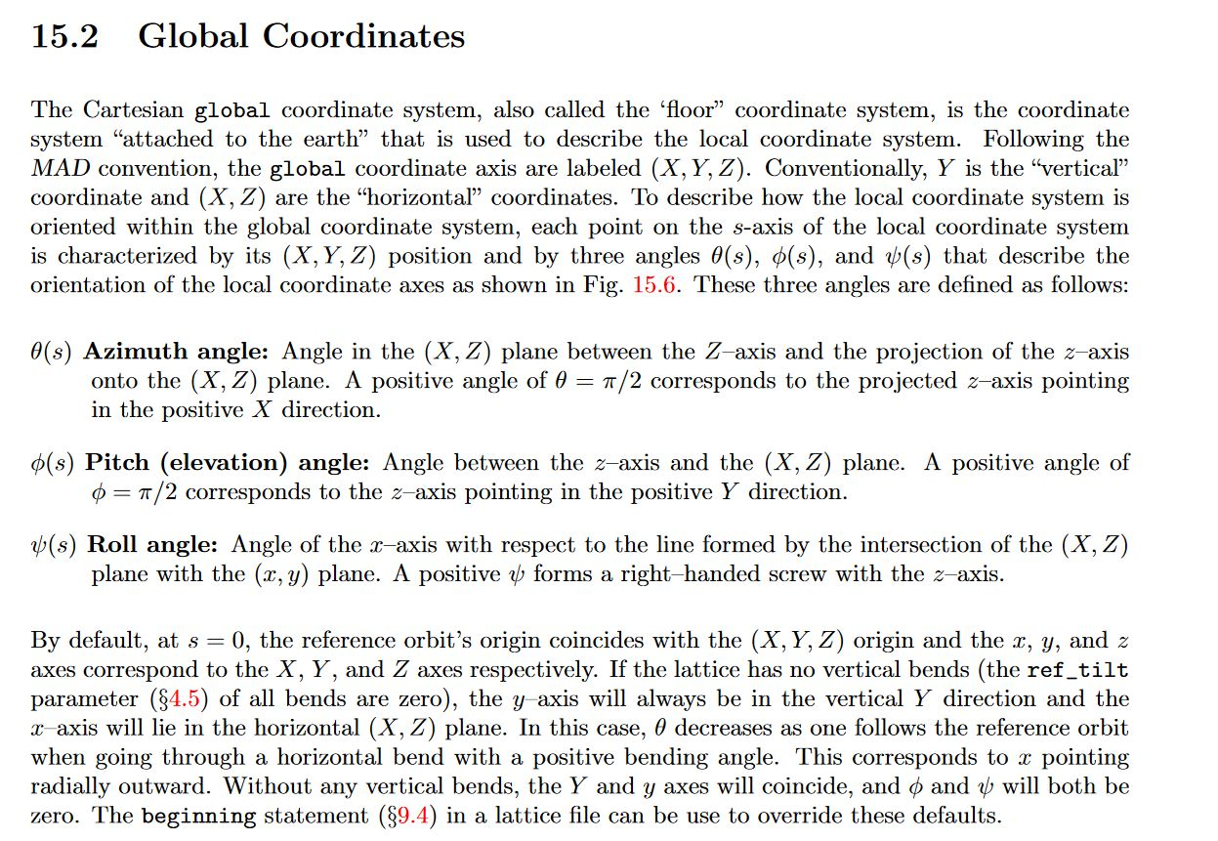

## Inventor

XYZ same as Bmad, Angles different. Transformation matrix from Bmad to Inventor:

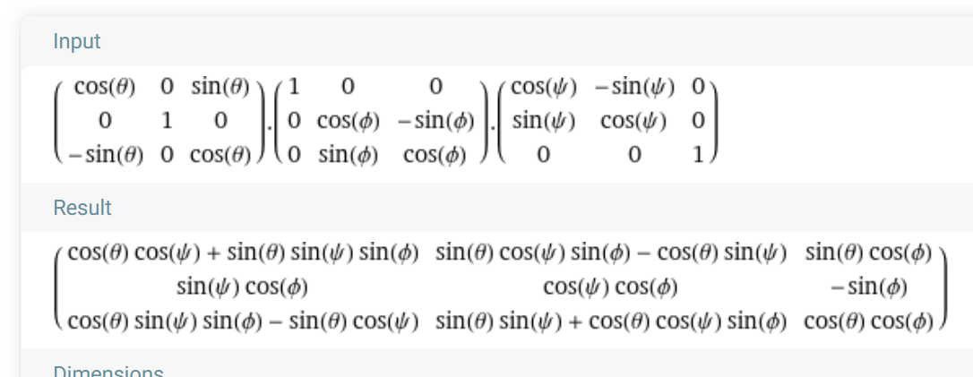

## Blender

Z up, X direction of beam, Y radially out. One Conversion that works:

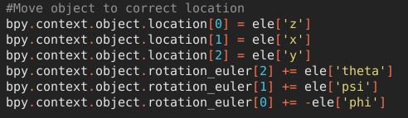

# Inventor

The quick brown fox jumped over the lazy dog.

# Blender

The quick brown fox jumped over the lazy dog.

# Appendices

The quick brown fox jumped over the lazy dog.